**MESD LMS Documentation – Add/Edit/Delete Subjects/Courses and Programs**

**Purpose**

To facilitate the addition, editing and deleting subjects, courses and programs.

**Background**

This module handles requests directly from Super Admins **(**IT officers at School level, Regional level, and Head -Q)within the Moodle system, allowing adding, editing and deletion of subjects/courses/programs.

**Usage**

**SUBJECTS/COURSES**

**Adding a Subject/Course**

1. Login as a Super Admin.
2. Go to ‘*Site Administration*’ > ‘*Courses*’ tab. Under the Courses category click on ‘*Manage courses and categories*’.
3. Creating a new category for the new subject/course
   1. Click on the ‘*Create new category*’ button. Here you can give the category a name e.g. Mathematics. Add the category ID (If the ID is not required leave blank), and *Description*. Sub Categories can be set in the *Parent category* drop box. This is if the category is a sub category of an existing Category.

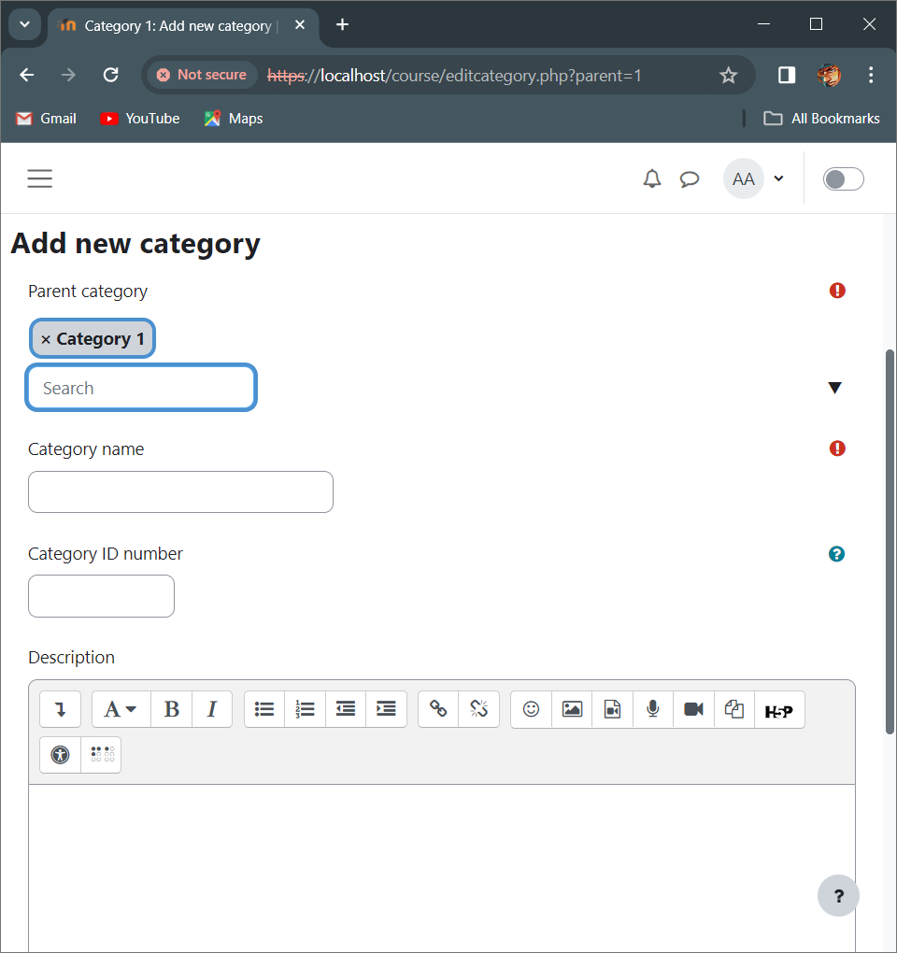

Click this drop down and select ‘Top’ to make this new category a main category.

Click on the X to remove the ‘Category 1’ from the main category.

* 1. When finished click ‘*Create Category’.*

1. Create new course
   1. Scroll down an existing category and click on *‘Create new course’* to get started.

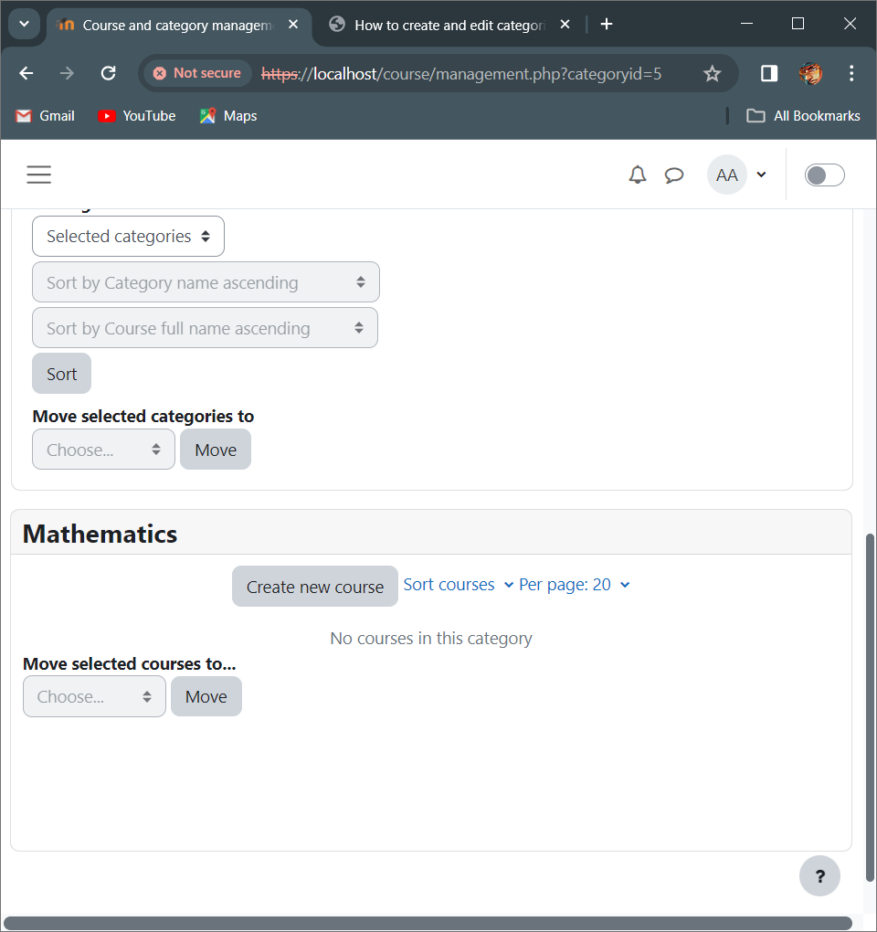

* 1. Add required information as to course requirements under each required form.

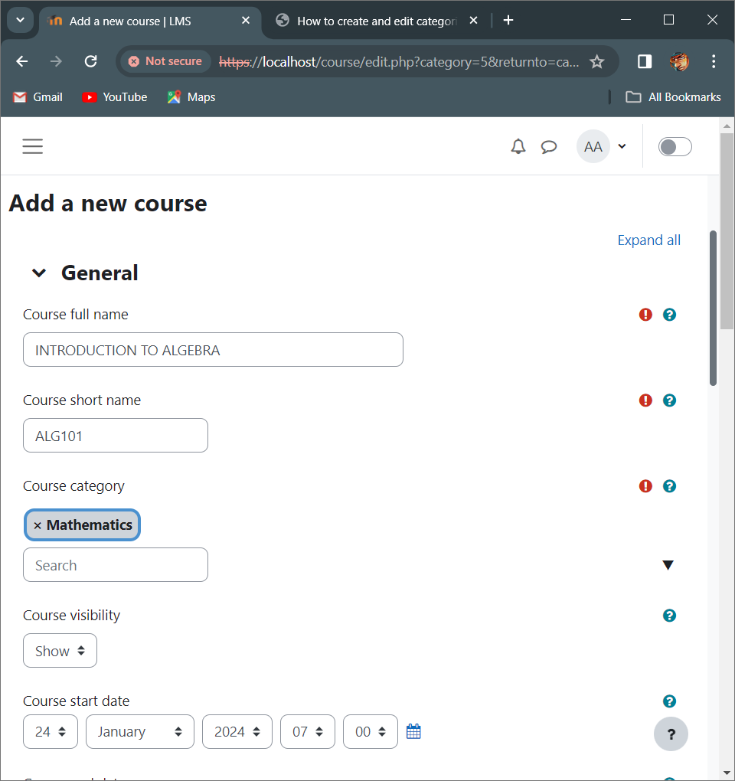

* 1. There are other optional/specific fields you can edit about the course. Scroll down and open the drop drowns to reveal other course editing options.
  2. When done click on the ‘*Save and return*’ button.

**Editing a Subject/Course**

1. Login as a Super Admin.
2. Go to ‘*Site Administration*’ > ‘*Courses*’ tab. Under the Courses category click on ‘*Manage courses and categories*’.
3. Search for the course or course category you want to edit.
4. Click on the cog wheel icon to enter the edit page for the selected course.

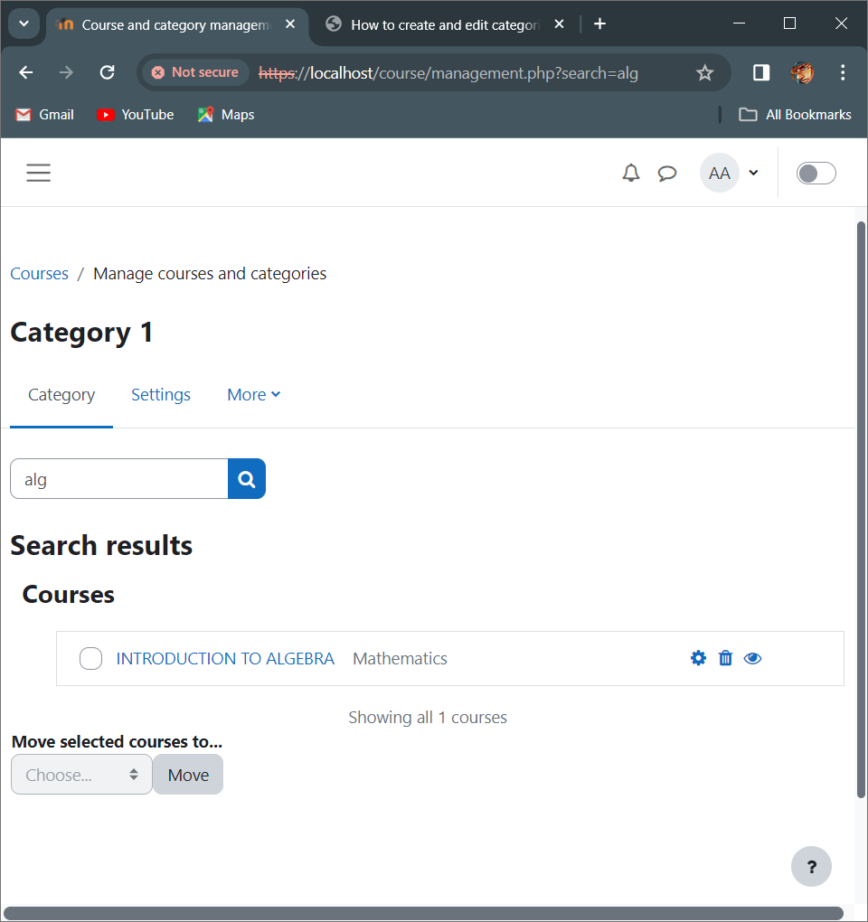

Click on this cog wheel to edit.

1. Proceed to edit the course then click on the *‘Save and display’* button at the bottom once done.

**Deleting a Subject/Course**

1. Login as a Super Admin.
2. Go to ‘*Site Administration*’ > ‘*Courses*’ tab. Under the Courses category click on ‘*Manage courses and categories*’.
3. Search for the course or category you wish to delete.
4. Click on the trash can icon to delete the course you have selected.



Click on this trash can icon to delete the course.

1. You will be greeted with a prompt page. Select Delete to proceed to remove the course from the database.

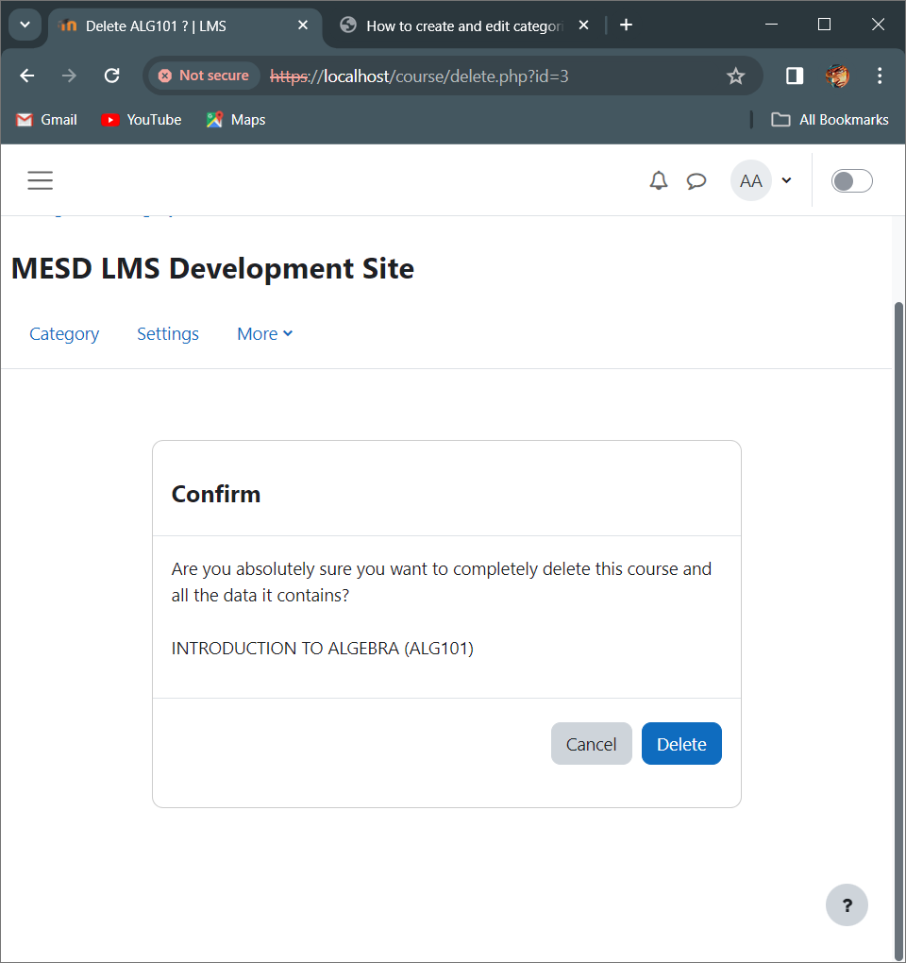

**PROGRAMS**

**Adding a new program**

1. Login as a Super Admin.
2. Go to ‘*Site Administration*’ > ‘*General*’ tab. Under the Programs category click on ‘*Program management’*.
3. Click on the *‘Add program’* button to add a new program.

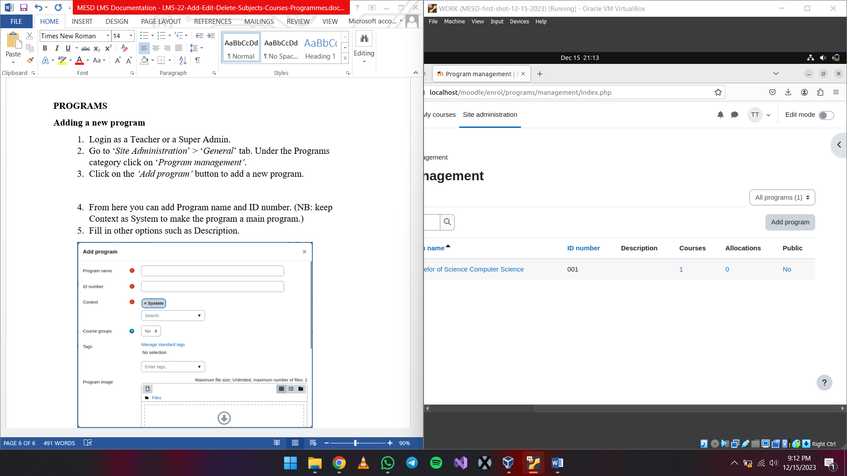

1. From here you can add Program name and ID number. (NB: keep Context as System to make the program a main program.)
2. Fill in other options such as Description.

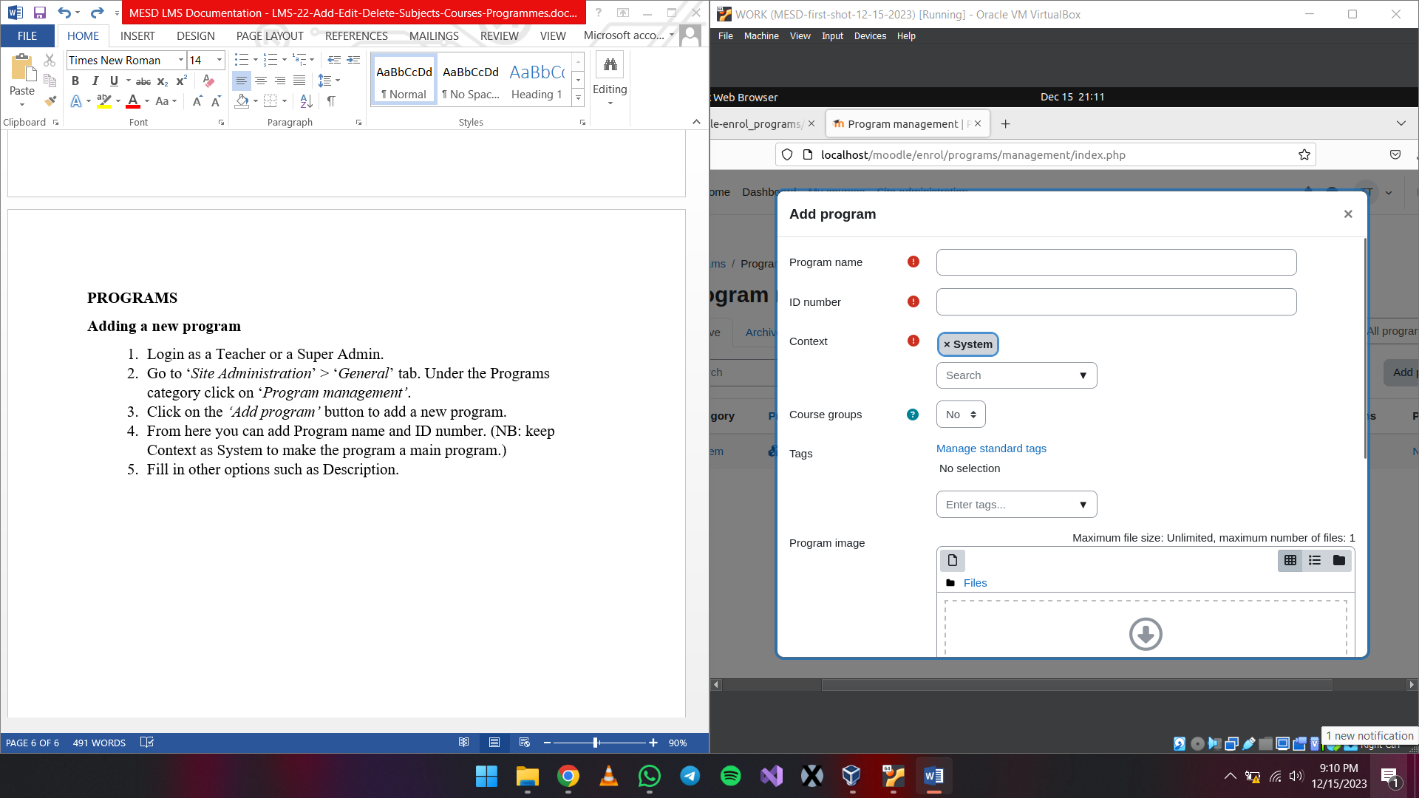

**Adding a course to a program**

1. Login as a Super Admin.
2. Go to ‘*Site Administration*’ > ‘*General*’ tab. Under the Programs category click on ‘*Program management’*.
3. Search for the program you want to add a course to or just find it from the list.

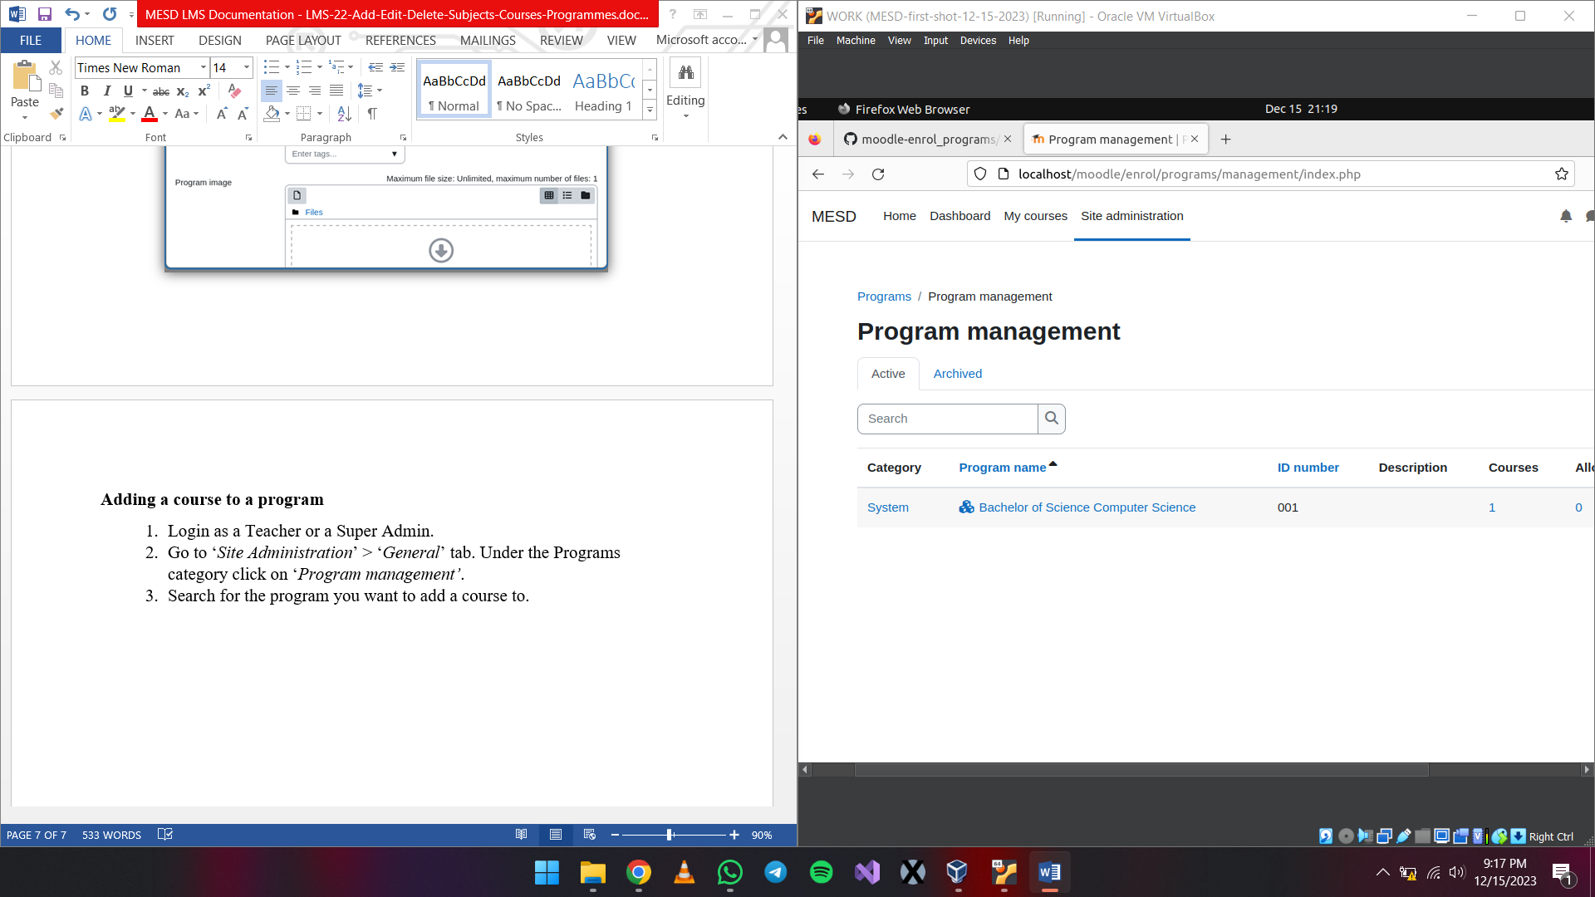

1. Click on the program.



1. Open the content tab then click on the plus icon under Actions to proceed.

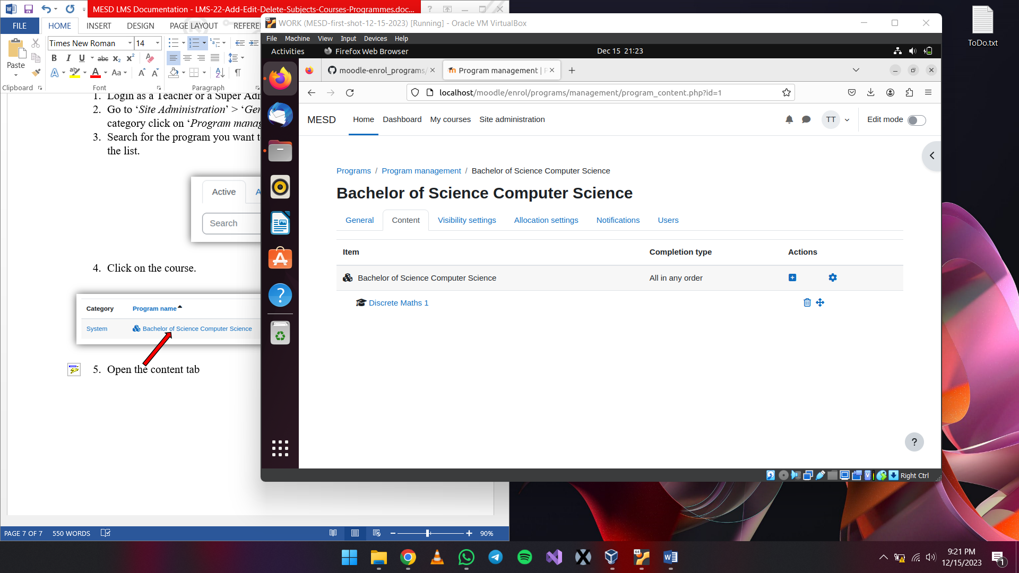

1. Click the plus icon
2. Click on Content
3. You will get a pop up box. Select the course under the drop down and hit the *‘Append item’* button to finalize adding the course.

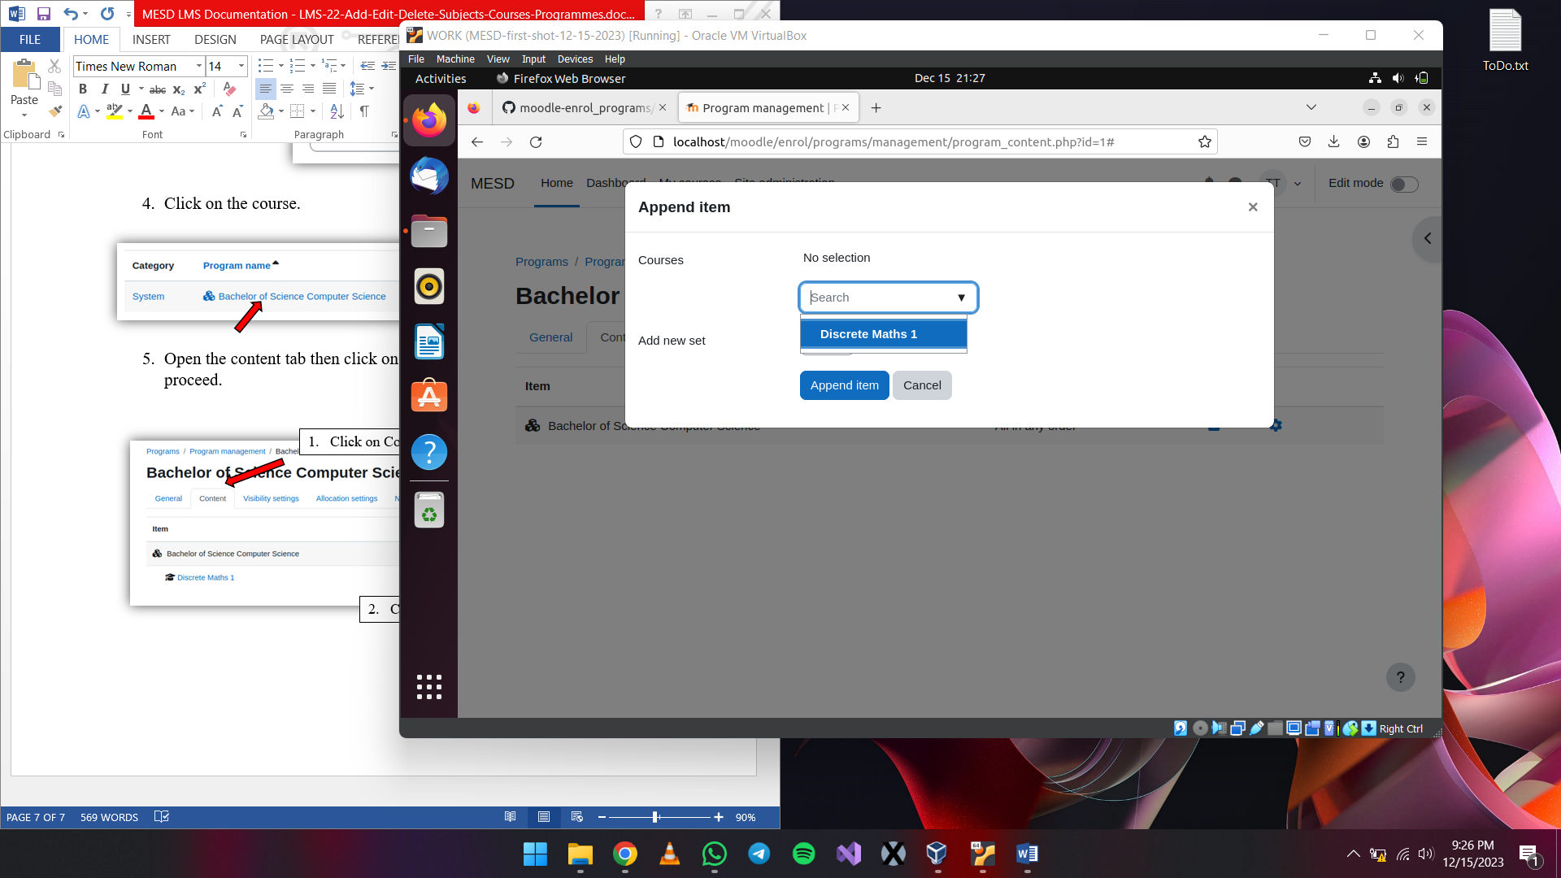

**Removing a course from a program**

1. Login as a Super Admin.
2. Go to ‘*Site Administration*’ > ‘*General*’ tab. Under the Programs category click on ‘*Program management’*.
3. Search for the program you want to remove a course from or just find it from the list.
4. Click on the course.
5. Open the content tab then click on the trash can icon under Actions next to the course you want to remove to proceed.

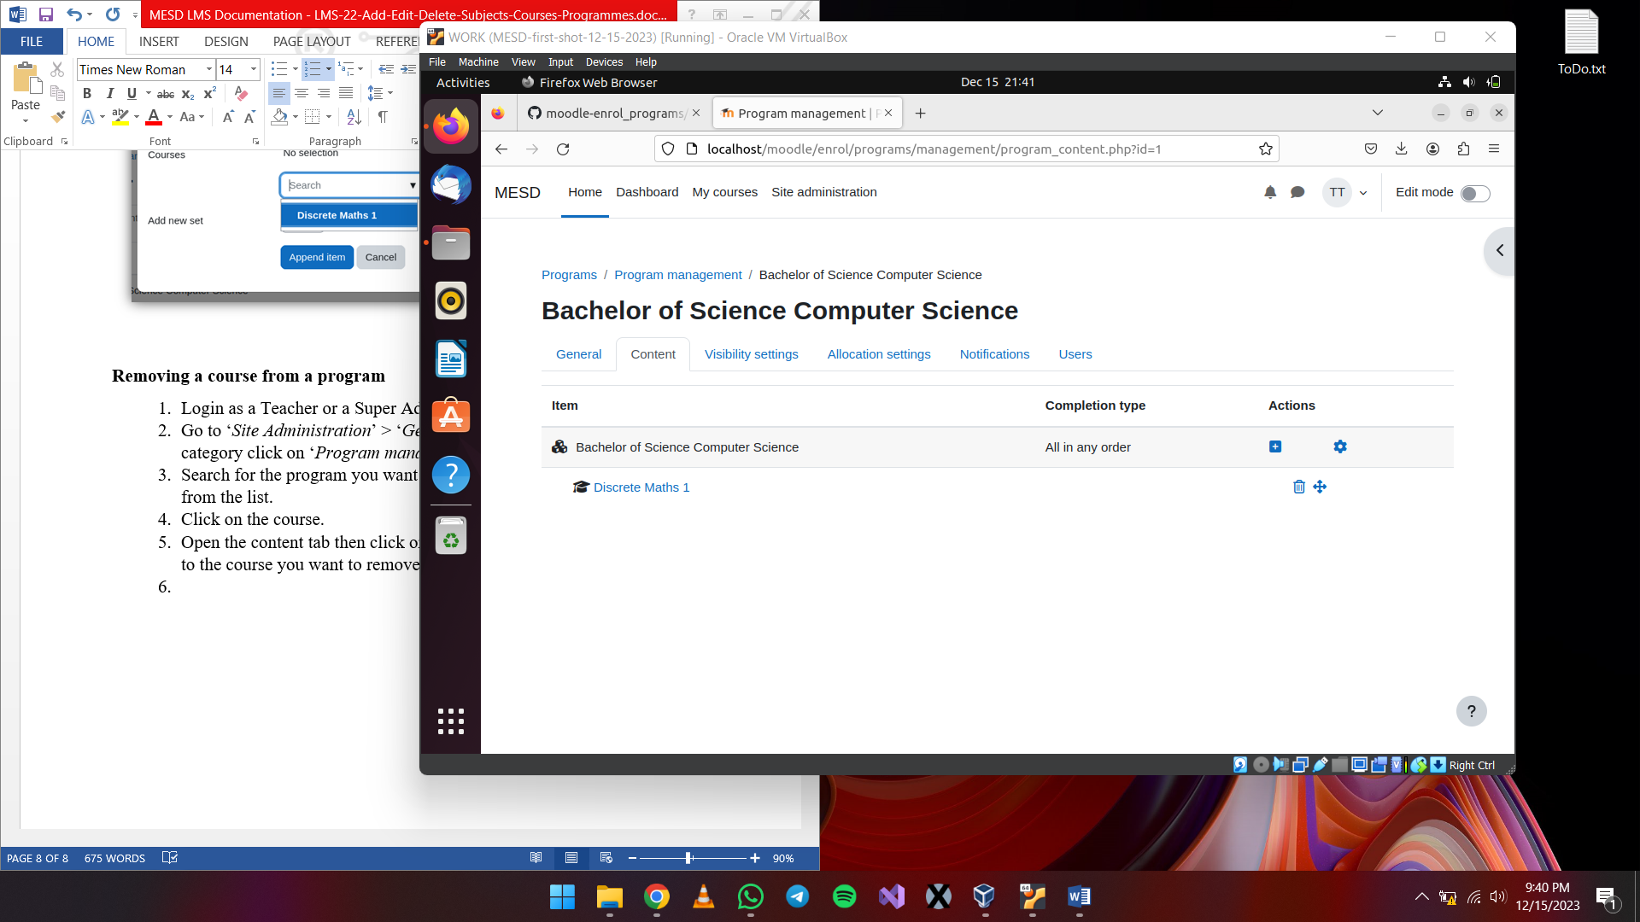

1. Click on the ‘Remove course’ button once the pop up is shown to finalize removing the course.

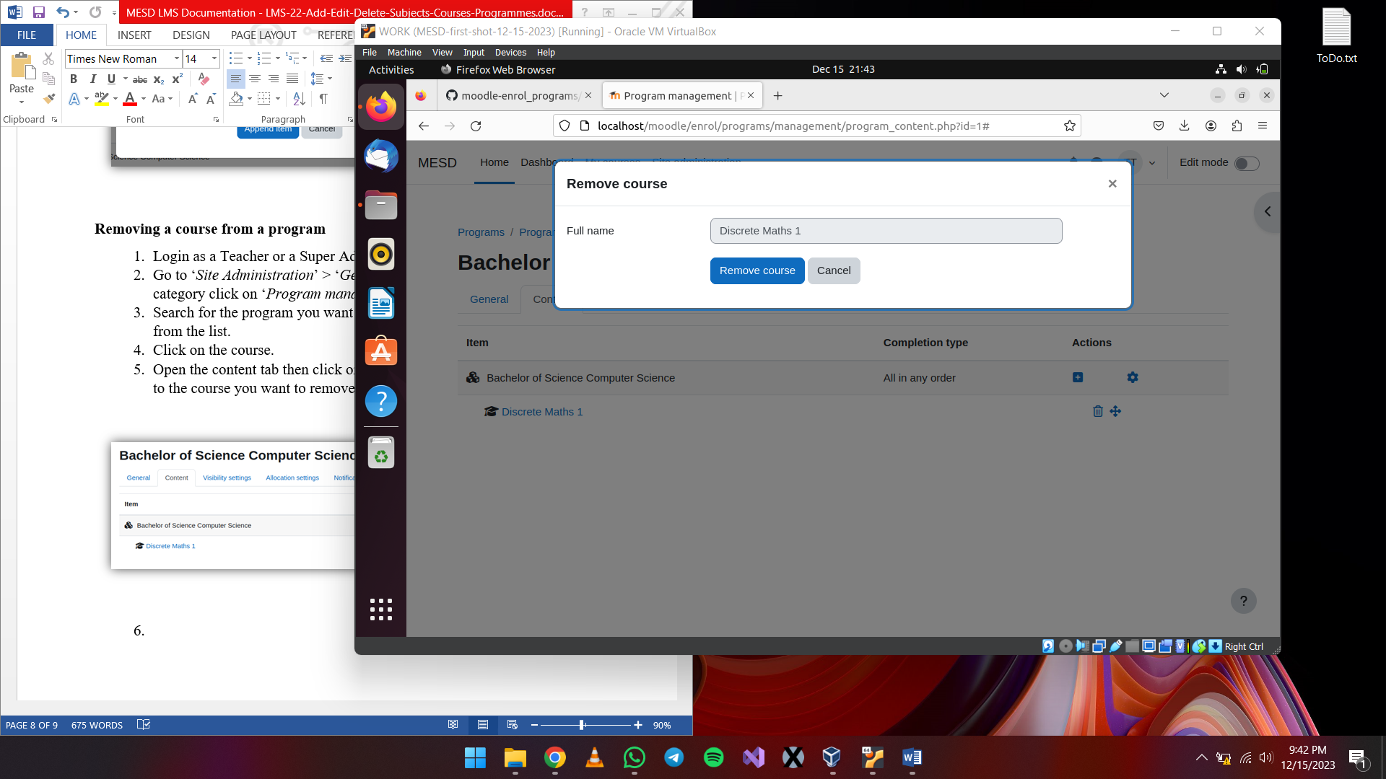

**Deleting, editing a program**

1. Login as an Educator or a Super Admin.
2. Go to ‘*Site Administration*’ > ‘*General*’ tab. Under the Programs category click on ‘*Program management’*.
3. Search for the program you want to delete or edit or find it in the list.
4. Removing the program
   1. Click on the program name.
   2. While under the General tab click on the *‘Delete program’* button.

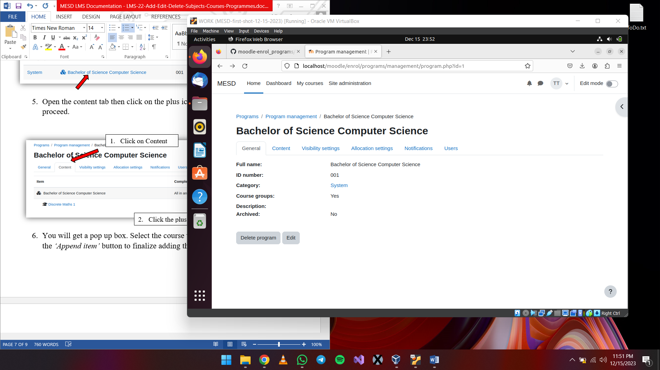

1. Editing a program
   1. Click on the program name.
   2. While under the General tab click on the *‘Edit’* button.



* 1. A pop up will be displayed then from there the program can be edited.